Day2
1) S17 - DOM to Selenium Code
DOM to Selenium Code Give the DOM as input Leaftaps login and generate the playwright typescript /Selenium Java or any thing of your choice
with Different models using temperature
Temperature 0.1
Prompt Request:
{
"messages": [
{
"role": "user",
"content": "As an Automation Architect, use the instructions below, I — INSTRUCTION\nAnalyze the given DOM and write selenium Java test case for Login negative scenario.\n\nMANDATORY RULES:\n1)Write only Java code, \n2) Inlcude Setup and teardown methods, \n3)Use this DOM: <body><div id=\"top\"></div><div id=\"container\"><div id=\"header\"><div id=\"logo\"><img src=\"/opentaps_images/opentaps_logo.png\"></div><div id=\"title\"></div></div><style type=\"text/css\">.gray-panel-header{background:gray;color:white;font:bold 11px tahoma,arial,verdana,sans-serif;padding:5px 2px 4px 20px;border:1px gray;line-height:15px}.rss-frame-section{width:245px;margin-left:0px;margin-right:auto;margin-top:20px}.rss-tabletext,.rss-tabletext a:link,.rss-tabletext a:visited{font-size:10px;text-decoration:none;font-family:Verdana,Arial,Helvetica,sans-serif;color:black}.rss-tabletext a:hover{text-decoration:underline}.rss-frame-section-body{background-color:#FFFFFF;padding:4px;border:0px solid #FFFFFF}img{max-width:99vw !important;max-height:99vh !important}.bg{background-image:url('/opentaps_images/4.png');background-repeat:no-repeat;background-size:cover;background-position:left;height:60vh;width:70vw}.bg1{background-image:url('/opentaps_images/3.png');background-repeat:no-repeat;background-size:cover;background-position:left;height:60vh;width:70vw}</style><script>function FitImagesToScreen(){var images=document.getElementsByTagName('img');if(images.length>0){document.styleSheets[1].rules[0].style[\"max-height\"]=((100/images.length)-1)+\"vh\";for(var i=0;i<images.length;i++){if(images[i].width>=(window.innerWidth-10)){images[i].style.width='auto'}}}}</script><div><div id=\"form\" onload=\"FitImagesToScreen()\" onresize=\"FitImagesToScreen()\"><h2>Leaftaps Login</h2><form id=\"login\" method=\"post\" action=\"/opentaps/control/login;jsessionid=8F119ABA081E08AE34329AF1F6B9785F.jvm1\"><p class=\"top\"><label for=\"username\">Username</label><input class=\"inputLogin\" type=\"text\" id=\"username\" name=\"USERNAME\" size=\"50\"></p><p><label for=\"password\">Password</label><input class=\"inputLogin\" type=\"password\" id=\"password\" name=\"PASSWORD\" size=\"50\"></p><p><input class=\"decorativeSubmit\" type=\"submit\" value=\"Login\"></p></form><br><br></div></div></div><div id=\"footer\"><div id=\"appDescr\" align=\"left\">Welcome to Leaftaps Application - TestLeaf environment for automation engineering learning.</div></div></body> \n\nOUTPUT RULES:\n- Return ONLY executable Java code\n- No markdown\n- No additional text\n\nCONTEXT:\nAct as an Automation Assistant with strong Selenium and TestNG expertise.\n\nPERSONA:\nAct as a Senior Test Automation Architect reviewing production-grade automation code.\n\nTONE:\nStrictly professional"
},
{
"role": "system",
"content": "As an AI Assistant give me a selenium java code with TestNG"
},
{
"role": "assistant",
"content": "only Java selenium code should be displayed along with the comments"
}
],
"model": "openai/gpt-oss-120b",
"temperature": 0.1,
"include_reasoning":true
}

Output Code: Tmperature 0.1
import org.openqa.selenium.By;
import org.openqa.selenium.WebDriver;
import org.openqa.selenium.WebElement;
import org.openqa.selenium.chrome.ChromeDriver;
import org.openqa.selenium.chrome.ChromeOptions;
import org.testng.Assert;
import org.testng.annotations.AfterClass;
import org.testng.annotations.BeforeClass;
import org.testng.annotations.Test;

public class LoginNegativeTest {

private WebDriver driver;
private final String baseUrl = "http://your-application-url.com"; // Replace with actual URL

@BeforeClass
public void setUp() {
// Set path to chromedriver if not in system PATH
// System.setProperty("webdriver.chrome.driver", "/path/to/chromedriver");

ChromeOptions options = new ChromeOptions();
options.addArguments("--headless"); // Remove to see browser UI

driver = new ChromeDriver(options);
driver.manage().window().maximize();
driver.get(baseUrl);
}

@Test
public void testInvalidLogin() {

// Enter invalid username
WebElement usernameField = driver.findElement(By.id("username"));
usernameField.clear();
usernameField.sendKeys("invalidUser");

// Enter invalid password
WebElement passwordField = driver.findElement(By.id("password"));
passwordField.clear();
passwordField.sendKeys("wrongPass");

// Click Login button
WebElement loginButton =
driver.findElement(By.cssSelector("input.decorativeSubmit"));
loginButton.click();

// Verify login failure by checking presence of login form
boolean isLoginFormPresent =
driver.findElements(By.id("login")).size() > 0;

Assert.assertTrue(
isLoginFormPresent,
"Login form should still be present after failed login"
);

// Verify URL has not changed to post-login page
String currentUrl = driver.getCurrentUrl();
Assert.assertTrue(
currentUrl.contains("/opentaps/control/login"),
"URL should still contain login path after failure"
);
}

@AfterClass
public void tearDown() {
if (driver != null) {
driver.quit();
}
}
}

Repeat for Temperature 0.1
import org.openqa.selenium.By;
import org.openqa.selenium.WebDriver;
import org.openqa.selenium.WebElement;
import org.openqa.selenium.chrome.ChromeDriver;
import org.openqa.selenium.chrome.ChromeOptions;
import org.testng.Assert;
import org.testng.annotations.AfterClass;
import org.testng.annotations.BeforeClass;
import org.testng.annotations.Test;

public class LoginNegativeTest {

private WebDriver driver;
private final String baseUrl = "http://your-application-url.com"; // Replace with actual URL

@BeforeClass
public void setUp() {
// Set ChromeDriver path if not using WebDriverManager
// System.setProperty("webdriver.chrome.driver", "/path/to/chromedriver");

ChromeOptions options = new ChromeOptions();
options.addArguments("--headless"); // Remove to see browser UI

driver = new ChromeDriver(options);
driver.manage().window().maximize();
driver.get(baseUrl);
}

@Test
public void testInvalidLogin() {

// Enter invalid username
WebElement usernameField = driver.findElement(By.id("username"));
usernameField.clear();
usernameField.sendKeys("invalidUser");

// Enter invalid password
WebElement passwordField = driver.findElement(By.id("password"));
passwordField.clear();
passwordField.sendKeys("wrongPass");

// Click Login button
WebElement loginButton =
driver.findElement(By.cssSelector("input.decorativeSubmit"));
loginButton.click();

// Temporary wait for demo purposes (use explicit wait in real tests)
try {
Thread.sleep(2000);
} catch (InterruptedException ignored) {
}

// Verify that login failed by checking current URL
String currentUrl = driver.getCurrentUrl();
Assert.assertTrue(
currentUrl.contains("/opentaps/control/login"),
"Expected to remain on login page after invalid credentials, but navigated to: "
+ currentUrl
);

// Verify login form is still displayed
boolean isFormPresent =
driver.findElements(By.id("login")).size() > 0;

Assert.assertTrue(
isFormPresent,
"Login form should still be present after failed login."
);
}

@AfterClass
public void tearDown() {
if (driver != null) {
driver.quit();
}
}
}

Temperature:1
Output1
import org.openqa.selenium.By;
import org.openqa.selenium.WebDriver;
import org.openqa.selenium.WebElement;
import org.openqa.selenium.chrome.ChromeDriver;
import org.openqa.selenium.chrome.ChromeOptions;
import org.testng.Assert;
import org.testng.annotations.AfterClass;
import org.testng.annotations.BeforeClass;
import org.testng.annotations.Test;

import java.time.Duration;

public class LoginNegativeTest {

private WebDriver driver;
private static final String BASE_URL = "http://your-application-url.com"; // Replace with actual URL

@BeforeClass
public void setUp() {
// Set ChromeDriver path if not using WebDriverManager
// System.setProperty("webdriver.chrome.driver", "/path/to/chromedriver");

ChromeOptions options = new ChromeOptions();
options.addArguments("--headless"); // Remove to see browser UI

driver = new ChromeDriver(options);
driver.manage().timeouts().implicitlyWait(Duration.ofSeconds(10));
driver.manage().window().maximize();
driver.get(BASE_URL);
}

@Test
public void negativeLoginShouldStayOnLoginPage() {

// Locate login form elements
WebElement usernameField =
driver.findElement(By.id("username"));
WebElement passwordField =
driver.findElement(By.id("password"));
WebElement loginButton =
driver.findElement(By.cssSelector(
"input.decorativeSubmit[value='Login']"
));

// Enter invalid credentials
usernameField.clear();
usernameField.sendKeys("invalidUser");

passwordField.clear();
passwordField.sendKeys("wrongPass");

// Submit the form
loginButton.click();

// Verify login form is still displayed
WebElement loginForm = driver.findElement(By.id("login"));
Assert.assertTrue(
loginForm.isDisplayed(),
"Login form should remain visible after invalid login"
);

// Verify URL has not changed (still on login page)
String currentUrl = driver.getCurrentUrl();
Assert.assertTrue(
currentUrl.contains("/opentaps/control/login"),
"URL should still contain login path after failed login"
);
}

@AfterClass
public void tearDown() {
if (driver != null) {
driver.quit();
}
}
}

Output 2:
import org.openqa.selenium.By;
import org.openqa.selenium.WebDriver;
import org.openqa.selenium.WebElement;
import org.openqa.selenium.chrome.ChromeDriver;
import org.openqa.selenium.chrome.ChromeOptions;
import org.testng.Assert;
import org.testng.annotations.AfterClass;
import org.testng.annotations.BeforeClass;
import org.testng.annotations.Test;

public class LoginNegativeTest {

private WebDriver driver;
private static final String BASE_URL = "http://your-application-url.com"; // Replace with actual URL

@BeforeClass
public void setUp() {
// Set path to chromedriver if not in system PATH
// System.setProperty("webdriver.chrome.driver", "/path/to/chromedriver");

ChromeOptions options = new ChromeOptions();
options.addArguments("--headless"); // Remove to see browser UI

driver = new ChromeDriver(options);
driver.manage().window().maximize();
driver.get(BASE_URL);
}

@Test
public void testInvalidLogin() {

// Enter invalid username
WebElement usernameField = driver.findElement(By.id("username"));
usernameField.clear();
usernameField.sendKeys("invalidUser");

// Enter invalid password
WebElement passwordField = driver.findElement(By.id("password"));
passwordField.clear();
passwordField.sendKeys("wrongPass");

// Click Login button
WebElement loginButton =
driver.findElement(By.cssSelector("input.decorativeSubmit"));
loginButton.click();

// Verify login failure by checking presence of login form
boolean isLoginFormPresent =
driver.findElements(By.id("login")).size() > 0;

Assert.assertTrue(
isLoginFormPresent,
"Login form should still be present after failed login"
);

// Verify URL has not changed to post-login page
String currentUrl = driver.getCurrentUrl();
Assert.assertTrue(
currentUrl.contains("/opentaps/control/login"),
"URL should still contain login path after failure"
);
}

@AfterClass
public void tearDown() {
if (driver != null) {
driver.quit();
}
}
}

2)S21 - MultiLingual
Ask to generate any content in diff languages (Japanese,Tamil,Telugu of your choice) and check whether the ouput is correct .
Prompt request:
{
"model": "openai/gpt-oss-120b",
"temperature": 0.1,
"messages": [
{
"role": "system",
"content": "You are a professional translator"
},
{
"role": "user",
"content": "Translate the following test instructions into Japanese, Chinese, German, Spanish and Polish: ''I love to travel around the world'"
}
]
}
Output response:
"**Japanese:** \n私は世界中を旅行するのが大好きです。 \n\n**Chinese (Simplified):** \n我喜欢环游世界。 \n\n**German:** \nIch liebe es, um die Welt zu reisen. \n\n**Spanish:** \nMe encanta viajar por el mundo. \n\n**Polish:** \nKocham podróżować po świecie."

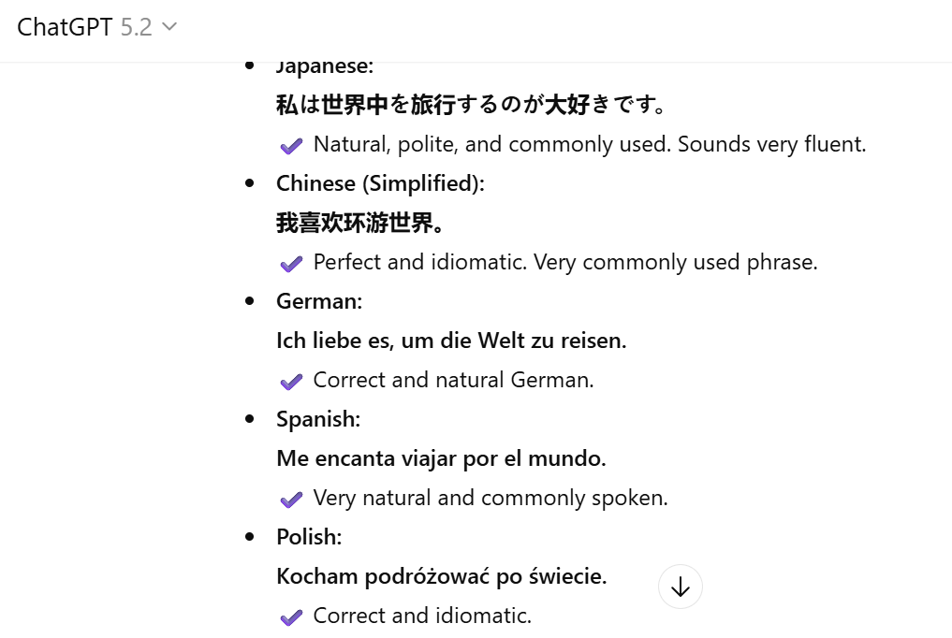
3)S16-Transcriptions
Try to generate the meeting summary of your office meeting or any files of your choice and Extract the text
(Use whisper-large-v3 and also the whisper-large-v3 Turbo)
whisper-large-v3 Turbo
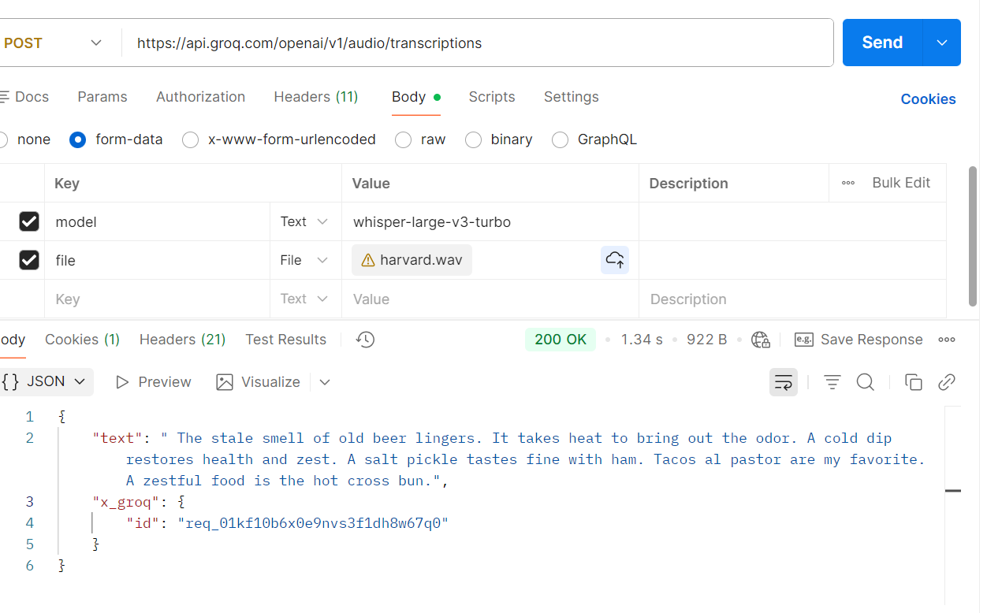
whisper-large-v3
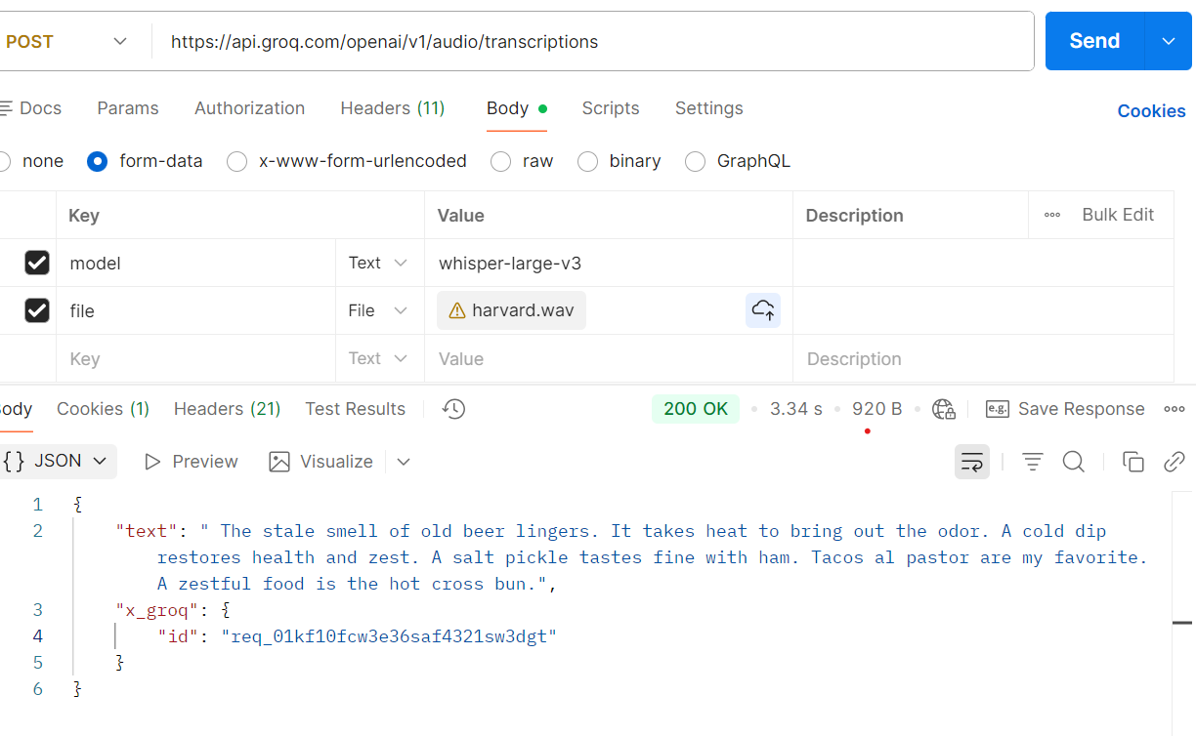
4)S09 - TextFromImage-Url - Free Image to URL Converter | Upload & Host Images Online Instantly
Use the vision model to extract the text from multilingual
{
"model": "meta-llama/llama-4-maverick-17b-128e-instruct",
"messages": [
{
"role": "user",
"content": [
{
"type": "text",
"text": "This is a image. Extract and return only the text exactly as shown, preserving case."
},
{
"type": "image_url",
"image_url": {
"url": "https://image2url.com/r2/default/images/1768487137163-9b732ecd-1b89-468d-8432-cd4d497cd058.jpg"
}
}
]
},
{
"role": "system",
"content": "You are a professional translator."
},
{
"role": "user",
"content": "Translate the text from above image into English'"
}
]
}

Output
